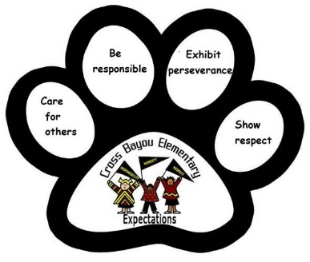 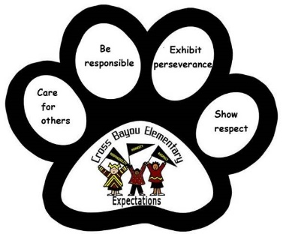

Cross Bayou Elementary School

Parent-Student-Teacher Compact 2022/2023

*Revised 7/22/19 – Reviewed 4/21/22*

**As a Parent/Guardian, I pledge to: As a Student, I pledge to: As a Teacher, I pledge to:**

Make sure my child arrives at school on time. Arrive at school on time. Provide a positive, safe and caring environment.

Support the School Wide Expectations. Follow School Wide Expectations. Apply School Wide Expectations fairly.

Sign my child’s agenda each night. Take responsibility for my actions and my learning. Communicate with parents in the agenda daily.

Collaborate with my child’s teachers. Follow directions the first time. Provide focused, planned and purposeful instruction.

Attend conferences. Come to class prepared. Provide information about your child’s progress.

Support School Activities. Respect myself and others. Seek ways to involve parents in class/school.

Ensure homework is completed. Complete and turn in homework on time. Monitor homework completion/accuracy.

Name: ____________________________ Name: ____________________________ Name: ____________________________

Signature: __________________________ Signature: __________________________ Signature: __________________________

Conference Date(s) : __________________ Date: _____________________________ Date: _____________________________

__________________________________

A pledge is a voluntary agreement designated to promote a partnership between home and school.

The Parent-Student-Teacher Compact meets the requirement of the Title 1 Federal Government.